**TRABAJO 4:**

**MODELO DE TRANSPORTE**

**ESTUDIANTE:**

**María Alejandra Marín Velásquez**

**CC 1128481980**

**DOCENTE:**

**Jaime Alejandro Ospina**

**Institución Universitaria Esumer**

**Medellín**

**2024**

**CONTENIDO**

**•** Introducción.

• Ejercicio propuesto, Modelos de transporte

• Solución

• Definición de variables

• Modelo matemático

• Solución Excel solver en 2 métodos

• Interpretación

• Python

**INTRODUCCION**

En el mundo empresarial, la optimización de costos de envío de mercancías es esencial para mantener la eficiencia y la rentabilidad. En este contexto, analizaremos un problema de optimización que involucra el cálculo de los costos de envío de una fábrica a diferentes ciudades, considerando la oferta y la demanda de productos.

**EJERCICIO PROPUESTO**

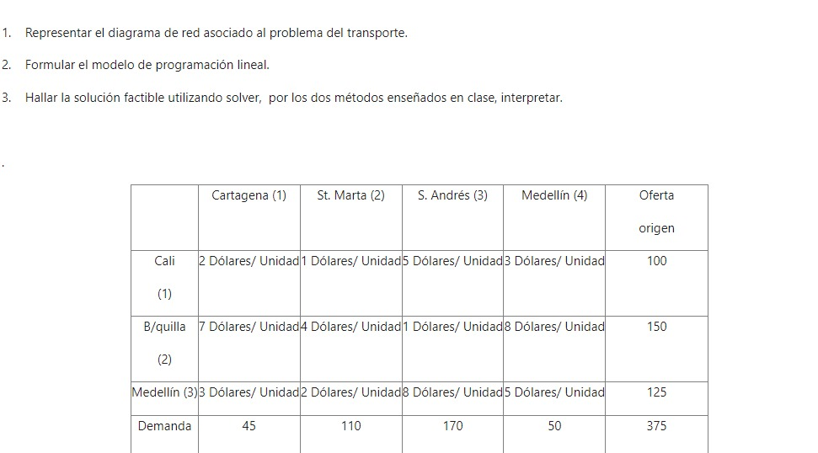

.

**SOLUCIÓN**

**Descripción del problema:** Tenemos información sobre la oferta de productos desde tres fábricas y la demanda de productos en cuatro ciudades diferentes. Además, conocemos los costos de envío asociados a cada combinación de fábrica y ciudad.

|  |  |  |  |  |  |  |  |
| --- | --- | --- | --- | --- | --- | --- | --- |
| **MATRIZ** |  | **c1** | **c2** | **c3** | **c4** |  | **oferta** |
| **fabrica 1** | 2 | 1 | 5 | 3 | <= | 100 |
| **fabrica 2** | 7 | 4 | 1 | 8 | <= | 150 |
| **fabrica 3** | 3 | 2 | 8 | 5 | <= | 125 |
| **Demanda** | 45 | 110 | 170 | 50 |  | 375 |

**DEFINICION DE VARIABLES**

Variable de análisis

|  |  |
| --- | --- |
| XiJ | = número electrodomésticos desde Fi hasta Cj |

Función objetivo

|  |  |
| --- | --- |
| Zmin= | 2X11+1X12+5X13+3X14+7X21+4X22+1X23+8X24+3X31+2X32+8X33+5X34 |

Restricciones de oferta

|  |  |  |  |  |  |  |
| --- | --- | --- | --- | --- | --- | --- |
| Restriccion1 | X1.1 | X1.2 | X1.3 | X1.4 | <= | 100 |
| Restriccion2 | X2.1 | X2.2 | X2.3 | X2.4 | <= | 150 |
| Restriccion3 | X3.1 | X3.2 | X3.3 | X3.4 | <= | 125 |

|  |  |  |  |  |  |  |  |
| --- | --- | --- | --- | --- | --- | --- | --- |
| Restricciones de demanda | | | | | | | |
| Restriccion4 | X1.1+X2.1+X3.1 | 45 |  |  |  |  |  |
| Restriccion5 | X1.2+X2.2+X3.2 | 110 |  |  |  |  |  |
| Restriccion6 | X1.3+X2.3+X3.3 | 170 |  |  |  |  |  |
| Restriccion7 | X1.4+X2.4+X3.4 | 50 |  |  |  |  |  |

**MODELO MATEMATICO**



**SOLUCIÓN EXCEL SOLVER EN 2 MÉTODOS**

**Método 1**

|  |  |  |  |  |  |  |  |  |  |  |  |  |  |  |  |  |  |  |  |  |  |  |  |  |  |
| --- | --- | --- | --- | --- | --- | --- | --- | --- | --- | --- | --- | --- | --- | --- | --- | --- | --- | --- | --- | --- | --- | --- | --- | --- | --- |
|  | | X11 | | X12 | | X13 | | X14 | | X21 | X22 | | X23 | | X24 | | X31 | | X32 | | X33 | | X34 |  |  |
| Zmin | | 2 | | 1 | | 5 | | 3 | | 7 | 4 | | 1 | | 8 | | 3 | | 2 | | 8 | | 5 | <= |  |
| R1 | | 1 | | 1 | | 1 | | 1 | |  |  | |  | |  | |  | |  | |  | |  | 100 | oferta |
| R2 | |  | |  | |  | |  | | 1 | 1 | | 1 | | 1 | |  | |  | |  | |  | 150 |  |
| R3 | |  | |  | |  | |  | |  |  | |  | |  | | 1 | | 1 | | 1 | | 1 | 125 |  |
| R4 | | 1 | |  | |  | |  | | 1 |  | |  | |  | | 1 | |  | |  | |  | 45 | demanda |
| R5 | |  | | 1 | |  | |  | |  | 1 | |  | |  | |  | | 1 | |  | |  | 110 |  |
| R6 | |  | |  | | 1 | |  | |  |  | | 1 | |  | |  | |  | | 1 | |  | 170 |  |
| R7 | |  | |  | |  | | 1 | |  |  | |  | |  | |  | |  | |  | | 1 | 50 |  |
|  | |  | |  | |  | |  | |  |  | |  | |  | |  | |  | |  | |  |  |  |
| Variables | | 0 | | 30 | | 20 | | 50 | | 0 | 0 | | 150 | | 0 | | 45 | | 80 | | 0 | | 0 |  |  |
| Zmin | 725 | |  | |  | | TABLA DE RESUMEN | | | | | | | | |  | |  | |  | |
| R1 | 100 | |  | |  | | ORIGEN | | DESTINO | | | COSTO | | UNIDADES | | COSTO PARCIAL | | | | | |
| R2 | 150 | |  | |  | | F1 | | C2 | | | 1 | | 30 | | 30 | |  | |  | |
| R3 | 125 | |  | |  | | F1 | | C3 | | | 5 | | 20 | | 100 | |  | |  | |
| R4 | 45 | |  | |  | | F1 | | C4 | | | 3 | | 50 | | 150 | |  | |  | |
| R5 | 110 | |  | |  | | F2 | | C3 | | | 1 | | 150 | | 150 | |  | |  | |
| R6 | 170 | |  | |  | | F3 | | C1 | | | 3 | | 45 | | 135 | |  | |  | |
| R7 | 50 | |  | |  | | F3 | | C2 | | | 2 | | 80 | | 160 | |  | |  | |
|  |  | |  | |  | |  | |  | | |  | | 375 | | 725 | |  | |  | |
|  |  | | Enviar 375 electrodomésticos me vale $725 | | | | | | | | | | | | |  | |  | |  | |

**MÉTODO 2**

|  |  |  |  |  |  |  |
| --- | --- | --- | --- | --- | --- | --- |
| MATRIZ COSTOS DE ENVIO POR UNIDAD | | | | |  |  |
|  |  |  |  |  |  |  |
|  | C1 | C2 | C3 | C4 | OFERTA |  |
| F1 | 2 | 1 | 5 | 3 | 100 |  |
| F2 | 7 | 4 | 1 | 8 | 150 |  |
| F3 | 3 | 2 | 8 | 5 | 125 |  |
| DEMANDA | 45 | 110 | 170 | 50 |  |  |
|  |  |  |  |  |  |  |
| MATRIZ DE UNIDADES ENVIADAS | | | |  |  |  |
|  | C1 | C2 | C3 | C4 |  | OFERTA |
| F1 | 0 | 30 | 20 | 50 | 100 | 100 |
| F2 | 0 | 0 | 150 | 0 | 150 | 150 |
| F3 | 45 | 80 | 0 | 0 | 125 | 125 |
|  | 45 | 110 | 170 | 50 |  |  |
| DEMANDA | 45 | 110 | 170 | 50 |  |  |
|  |  |  |  |  |  |  |
|  |  |  |  | Zmin | 725 |  |
|  |  |  |  |  |  |  |
| MATRZ DE COTOS PARCIALES | | | |  |  |  |
|  |  |  |  |  |  |  |
|  | C1 | C2 | C3 | C4 |  |  |
| F1 | 0 | 30 | 100 | 150 |  |  |
| F2 | 0 | 0 | 150 | 0 |  |  |
| F3 | 135 | 160 | 0 | 0 |  |  |

**INTERPRETACION**

Este ejercicio muestra cómo se distribuyen los productos desde las fábricas a las ciudades para minimizar los costos totales de envío, garantizando al mismo tiempo que se satisfaga la demanda de cada ciudad de manera eficiente. Esto demuestra la importancia de la optimización logística en la gestión de costos y la toma de decisiones empresariales.

**PYTHON**

!pip install pulp

from pulp import *

# Define los datos del problema

oferta = [100, 150, 125]  # Oferta de los orígenes

demanda = [45, 110, 170, 50]  # Demanda de los destinos

costos = [[2, 1, 5, 3],

          [7, 4, 1, 8],

          [3, 2, 8, 5]]  # Costos de transporte

# Crea el problema de minimización

prob = LpProblem("Problema de transporte", LpMinimize)

# Crea las variables de decisión

variables = {(i, j): LpVariable(f"x{i}{j}", lowBound=0) for i in range(len(oferta)) for j in range(len(demanda))}

# Define la función objetivo

prob += lpSum(costos[i][j] * variables[(i, j)] for i in range(len(oferta)) for j in range(len(demanda)))

# Define las restricciones de oferta

for i in range(len(oferta)):

    prob += lpSum(variables[(i, j)] for j in range(len(demanda))) <= oferta[i]

# Define las restricciones de demanda

for j in range(len(demanda)):

    prob += lpSum(variables[(i, j)] for i in range(len(oferta))) >= demanda[j]

# Resuelve el problema

prob.solve()

# Imprime el resultado

print("Estado:", LpStatus[prob.status])

print("Costo mínimo de transporte:", value(prob.objective))

# Imprime las cantidades óptimas transportadas

for v in prob.variables():

    print(v.name, "=", v.varValue)

Requirement already satisfied: pulp in /usr/local/lib/python3.10/dist-packages (2.8.0)

Estado: Optimal

Costo mínimo de transporte: 725.0

x00 = 0.0

x01 = 30.0

x02 = 20.0

x03 = 50.0

x10 = 0.0

x11 = 0.0

x12 = 150.0

x13 = 0.0

x20 = 45.0

x21 = 80.0

x22 = 0.0

x23 = 0.0